French South African Tech Labs

Season 3

-
APPLICATION FORM

Are you ready to join the French South African Tech Labs?
The FSAT Labs is an incubator and accelerator based in Cape Town that aims at fostering innovative tech start-ups. Based on the partnership between Methy’s Lab and Seda (Small Enterprise Development Agency), the FSAT Labs is a new service for entrepreneurs.
This first round of applications is open until May 27th, 2018 and the laureates will be part of the third cohort of entrepreneurs benefiting from the FSAT Labs’ hosting and coaching services. They will be incubated from mid-June 2018.

“To infinity and beyond!”

Do you have an idea that could change the world thanks to tech? Have you already created your own business and would you like to become a kick-ass entrepreneur?
The FSAT Labs is ready to welcome you and lead you to infinity and beyond!

Thanks to our deep expertise in tech sectors and our incredible team, you will follow an intensive program designed to propel your project, by taking your team from zero to hero.

How does it work? It very simple (BUT IT ALL GOES REALLY FAST, BE PREPARED!):
- Step 1: apply through this application form before May 27th!
- Step 2: if you are selected, you will need to be prepared for a pitching battle @ FSAT Labs (the incubator is based in Century City Cape Town). You will be notified on Fri, 1st June latest, for a provisional pitching session date is set on Wed, 6th June!
- Step 3: final decision will be given by Mon, 11th June for you and your team to embark on a 2-day Boot Camp Session starting Mon, 18th June! Incubation will last 6-months thereafter.
- Step 4: if your business is sustainable and you will be given the chance to integrate the acceleration program for up to 24 months with highly-competitive hosting and digital services tariffs provided by our partners.
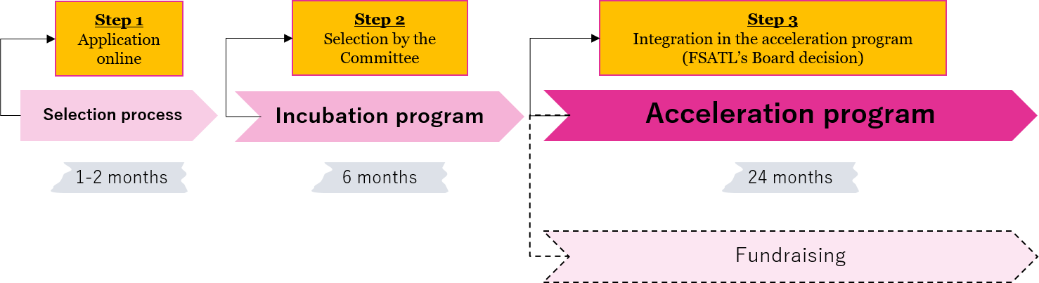
Please note that the key focus areas addressed by the FSAT Labs, reflecting the specialization areas of the founding members of the French Tech Cape Town ecosystem and the core track record of Methys Labs, are the 5 following sectors:
- SMART city - SMART home - SMART commerce - SMART media - SMART education
If you think you are fit enough to take up the challenge, we look forward to receiving your application. Don’t miss out on this incredible opportunity for a life-changing experience!

The French South African Tech Labs’ team

- PERSONAL INFORMATION
We need to decide who will be the main interlocutor for ease of communication. Don’t worry, we’ll get to each team member later on! For now, tell us a little more about you:
What’s your first name?
And your last name?
Could you pitch/describe yourself in 50 words?
What’s your citizenship?
What’s your ethnic group?
And what’s your email address?
Now what’s your phone number?
Please do not forget to add your international area code (+27 / +33...)
What’s your Skype ID?
What have you been doing (position held) in your project or startup?

Will you be available to dedicate 6 months fulltime to your start-up?
☐ YES ☐ NO

- YOUR PROJECT
Let’s talk about your project: business is business!
GENERAL INFORMATION:
- What is the name of your project?

- When did you start working on this project and what are your main achievements to date:
DD / MM / YYYY

- Where do you currently work on your project from?
☐ HOME
☐ OFFICE OF ANOTHER COMPANY
☐ ANOTHER INCUBATOR
☐ Other:
City / Country:

- What are the tech sectors into which your project falls? (one or several answers possible)

☐ SMART CITY
☐ SMART HOME
☐ SMART COMMERCE
☐ SMART MEDIA
☐ SMART EDUCATION
For your information:
- SMART home: Smart home technology, also known as home automation, provides homeowners security, comfort, convenience and energy efficiency by allowing them to control smart devices, often by a smart home app on their smartphone or other networked device.
- SMART city: Smart cities tend to take the Smart home concept to a city’s level adding Risk Management, Access & Mobility issues, all to improve people life in emerging countries, reduce environmental footprint and promote social inclusion.
- SMART commerce: Smart commerce empowers customers thanks to technology, allowing them to access and explore always more services and products with new, fast and simple user experience; it includes mobile based commerce, fintech, financial web services, banking and insurance inclusions, ...
- SMART media: game design, 3D animation and printers, Internet of Things, communication and marketing, big data
- SMART education: digital technologies applied to learning

- Elevator Pitch: describe your project in a tweet-like post (140 characters max.):

- Does your project has a website?
☐ YES ☐ NO
If yes, please indicate the address: http://

YOUR PRODUCT / SERVICE / TECHNOLOGY:
- Describe what problem you are trying to solve. How did you identify this problem?

- What is your solution? Why this solution is innovative?

- What are your revenue streams?

MARKET AND COMPETITION:
- Who are your (prospective) customers? What is your target market?

- Who are your competitors in South Africa and elsewhere? How is your solution different?

BUSINESS DEVELOPMENT:
- Do you already have a business model?

☐ YES ☐ NO
If yes, please attach it to your application form

- What are the main difficulties do you think you will face developing your business?

- What do you expect from the French South African Tech Labs? What are you needs?

- Have you thought of your development strategy? What are the major objectives of your company in the next two years (partnerships, funding, growth, etc.)?

FINANCE:
- How much have you invested in the company to date or have you planned to invest?
Please specify if this amount is in rands, euros or dollars

- Have you approached other investors/potential investors?

☐ YES ☐ NO

- Have you raised any funding for your company?
☐ YES ☐ NO

If so how much to date?
Please specify if this amount is in rands, euros or dollars

YOUR TEAM MEMBERS:
Surname | Name | Position in the company | Citizenship | Ethnic group | Gender  M/F | Highest Qualification

- What are the strengths AND the weaknesses of your team?

- Why do you really care about this project?

Thank you for your time!
If your application form is complete, please send it to contact@fsatlabs.co.za with your business plan or business model canvas if you already have one. If you have any questions, please feel free to drop us an email.
We will get back to you promptly to confirm we have received application. If your application is selected, you will be invited to pitch your project at the French South African Tech Labs and be notified on Fri, 1st June latest.

Good Luck!
We look forward to meeting you :)

